Science is a study of the natural world.

A person who studies science is a scientist.

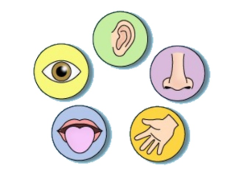
Observe – using your senses to notice details. (facts)
We use five senses: see, hear, touch, taste, smell

Predict – a guess using what you already know.

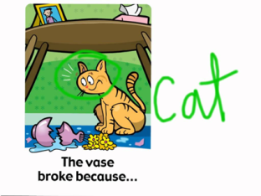
Infer - offering an explanation of what you observed. (based on what you see)

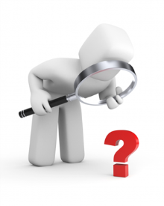
Investigation – a planned way to finding answers to a question.

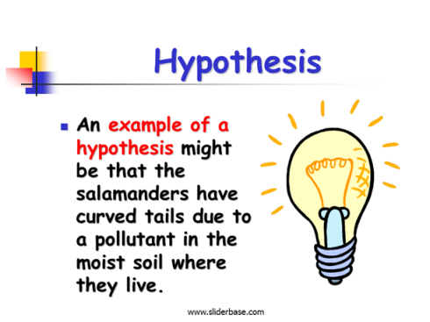
Hypothesis – a possible
explanation or answer to a question,
a testable statement.

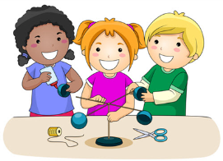
Experiment – a test done to gather evidence.
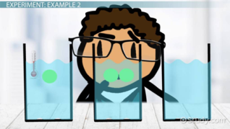
Variable – the one thing that changes in an experiment.

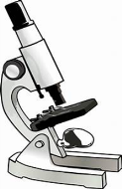
Microscope – a tool that magnifies objects that
are too tiny to be seen just with the eyes.
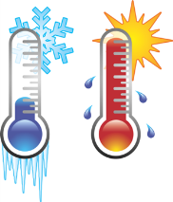

Temperature – a measurement of how hot or cold something is.

Tools used to measure volume:
Beaker Measuring Cup Graduated cylinder
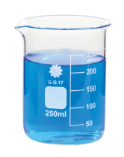
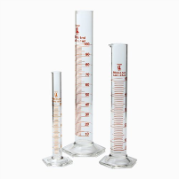
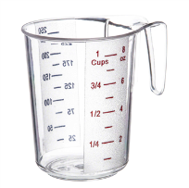

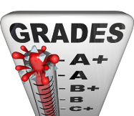
Data – individual facts, statistics and items of information.
For example, grades.
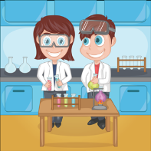
Evidence – the facts that show if a hypothesis was correct.

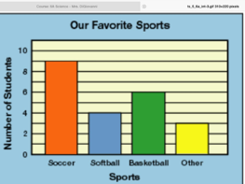
Bar Graph – a graph that shows how things compare.

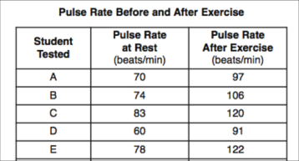
Data Table - a chart for holding numbers.

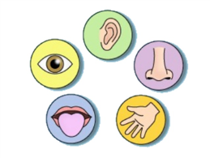
Observation is something that you see (observe) using your senses.
I can prove it with 5 senses

Inference – is something you think based on your observation. (what you see)

