Scientist’s Tools
Tools are used to measure lengths, volume, distance, mass, weight, volume, temperature and time.

Magnify – make things look bigger. (tools – microscope, magnifying lens)
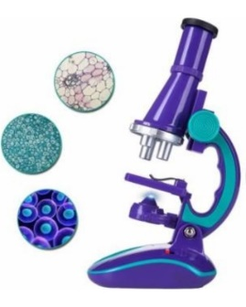

Temperature – measures how hot or cold something is in degrees. (tools - thermometer)
In the U.S. we use Fahrenheit.
In other countries, they use Celsius.
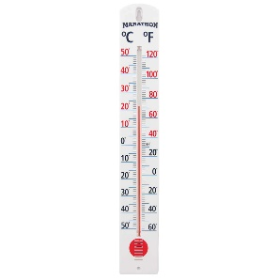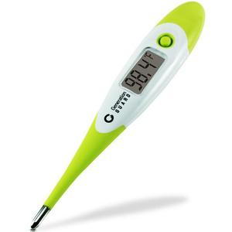

We measure length using a ruler, tape measure, meter stick.
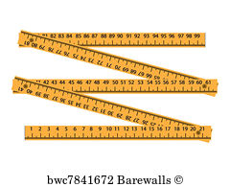
Scientists measure using the metric system.

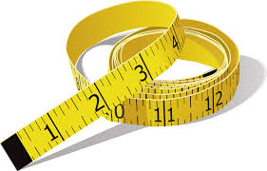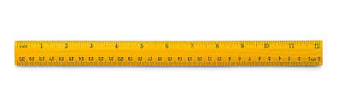

We measure volume using a measuring cup, beaker, and graduated cylinder.
Volume is the amount of space that something takes up. (tools – graduated cylinder, beaker)
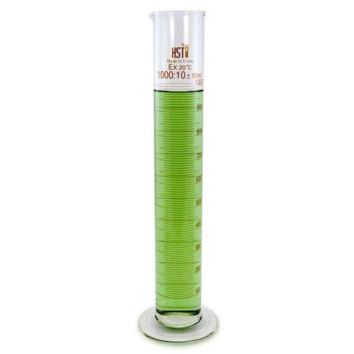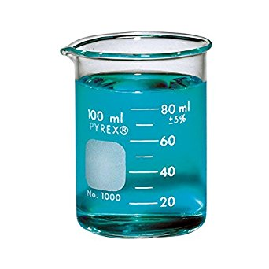

Measuring Mass
Mass is the amount of matter in something.
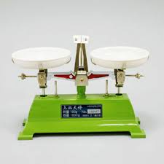
A balance scale compares the mass of two objects.
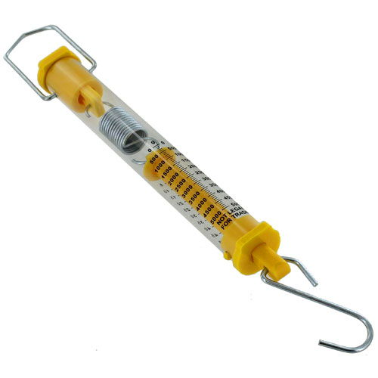

A spring scale measures the mass of one object.

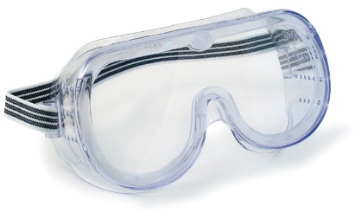
Other tools:
Goggles – protect your eyes during experiments.

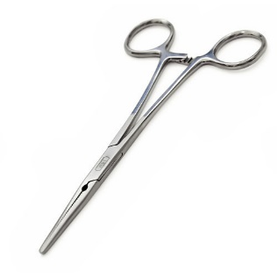
Forceps (tweezers) – used to pick up objects

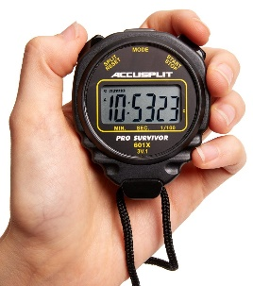
Stopwatch – measures time (same as clock) – how long does it take for something to happen.

